Digital Assistant
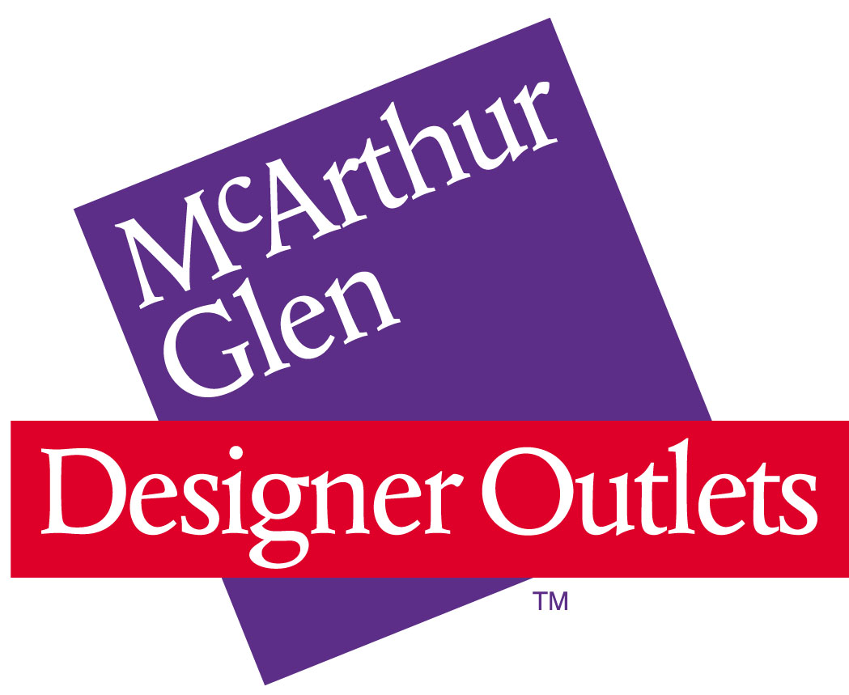

About McArthurGlen
McArthurGlen Group is the leading developer, owner and manager of designer outlet villages in Europe. The Group partners with the world's leading fashion and luxury brands, offering more than 75 million annual customers all-year-round discounts of 30-70% in attractive village environments. Currently, McArthurGlen has 20 designer outlets with nearly 600,000m² of retail space.
The Role
The role holder, reporting to the Centre Marketing Manager will work closely with the Centre Teams and Digital Agencies to ensure the respective regional MG websites are up to date with offers, brands, campaigns and news in accordance with both the monthly content plan and any ad hoc content deliverables.

Location
Athens

Internship Description - Activities
- Manage the Digital Content Process – making sure the local teams are submitting/following the guidelines
- Update our accounts on Facebook, Twitter and Instagram
- Ensure the websites adhere to the Digital Style Guide and Tone of Voice guidelines
- Ensure all content is correctly updated for all language versions of each individual website
- Work directly with the Centre Marketing Manager and Executives on updating the websites with global promotions, news and offers
- Supporting the Digital Project Manager with ad-hoc requests
- Upload imagery on the websites for each new season
- Regularly proof the websites and check links

Your Profile / Knowledge and Skills
- Degree in Marketing, Digital Marketing or Communication
- Fluent English (written and spoken)
- Experience using CMS – Umbraco
- Knowledge of HTML
- Photoshop and basic re-sizing

Please send your CV in English to recruitment.se@mcarthurglen.com quoting: DAA

