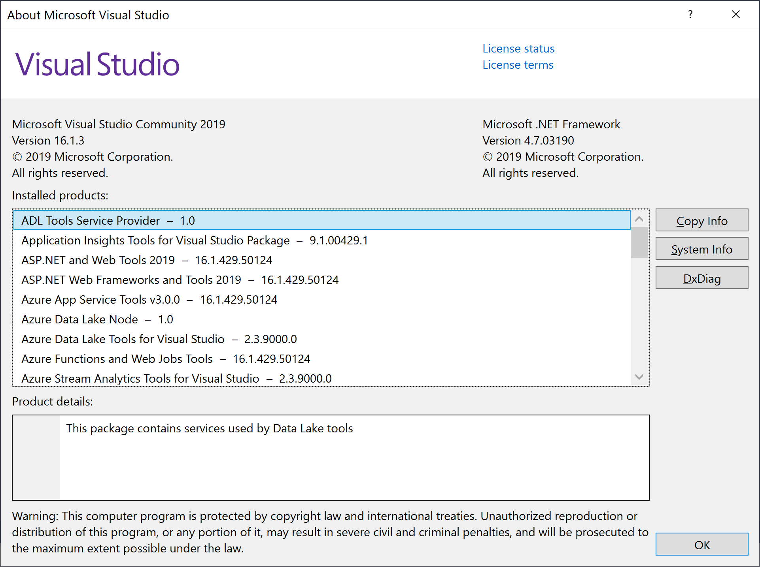

Microsoft Visual Studio Community 2019

Version 16.1.3

VisualStudio.16.Release/16.1.3+29009.5

Microsoft .NET Framework

Version 4.7.03190

Installed Version: Community

ADL Tools Service Provider 1.0

This package contains services used by Data Lake tools

Application Insights Tools for Visual Studio Package 9.1.00429.1

Application Insights Tools for Visual Studio

ASP.NET and Web Tools 2019 16.1.429.50124

ASP.NET and Web Tools 2019

ASP.NET Web Frameworks and Tools 2019 16.1.429.50124

For additional information, visit https://www.asp.net/

Azure App Service Tools v3.0.0 16.1.429.50124

Azure App Service Tools v3.0.0

Azure Data Lake Node 1.0

This package contains the Data Lake integration nodes for Server Explorer.

Azure Data Lake Tools for Visual Studio 2.3.9000.0

Microsoft Azure Data Lake Tools for Visual Studio

Azure Functions and Web Jobs Tools 16.1.429.50124

Azure Functions and Web Jobs Tools

Azure Stream Analytics Tools for Visual Studio 2.3.9000.0

Microsoft Azure Stream Analytics Tools for Visual Studio

C# Tools 3.1.1-beta4-19281-06+58a4b1e79aea28115e66b06f850c83a3f1fcb6d3

C# components used in the IDE. Depending on your project type and settings, a different version of the compiler may be used.

Common Azure Tools 1.10

Provides common services for use by Azure Mobile Services and Microsoft Azure Tools.

Fabric.DiagnosticEvents 1.0

Fabric Diagnostic Events

IntelliCode Extension 1.0

IntelliCode Visual Studio Extension Detailed Info

Microsoft Azure HDInsight Azure Node 2.3.9000.0

HDInsight Node under Azure Node

Microsoft Azure Hive Query Language Service 2.3.9000.0

Language service for Hive query

Microsoft Azure Service Fabric Tools for Visual Studio 2.5

Microsoft Azure Service Fabric Tools for Visual Studio

Microsoft Azure Stream Analytics Language Service 2.3.9000.0

Language service for Azure Stream Analytics

Microsoft Azure Stream Analytics Node 1.0

Azure Stream Analytics Node under Azure Node

Microsoft Azure Tools 2.9

Microsoft Azure Tools for Microsoft Visual Studio 0x10 - v2.9.20419.2

Microsoft Continuous Delivery Tools for Visual Studio 0.4

Simplifying the configuration of Azure DevOps pipelines from within the Visual Studio IDE.

Microsoft JVM Debugger 1.0

Provides support for connecting the Visual Studio debugger to JDWP compatible Java Virtual Machines

Microsoft Library Manager 1.0

Install client-side libraries easily to any web project

Microsoft MI-Based Debugger 1.0

Provides support for connecting Visual Studio to MI compatible debuggers

Microsoft Visual Studio Tools for Containers 1.1

Develop, run, validate your ASP.NET Core applications in the target environment. F5 your application directly into a container with debugging, or CTRL + F5 to edit & refresh your app without having to rebuild the container.

NuGet Package Manager 5.1.0

NuGet Package Manager in Visual Studio. For more information about NuGet, visit https://docs.nuget.org/

ProjectServicesPackage Extension 1.0

ProjectServicesPackage Visual Studio Extension Detailed Info

ResourcePackage Extension 1.0

ResourcePackage Visual Studio Extension Detailed Info

ResourcePackage Extension 1.0

ResourcePackage Visual Studio Extension Detailed Info

SQL Server Data Tools 16.0.61904.23160

Microsoft SQL Server Data Tools

ToolWindowHostedEditor 1.0

Hosting json editor into a tool window

TypeScript Tools 16.0.10506.2004

TypeScript Tools for Microsoft Visual Studio

Visual Basic Tools 3.1.1-beta4-19281-06+58a4b1e79aea28115e66b06f850c83a3f1fcb6d3

Visual Basic components used in the IDE. Depending on your project type and settings, a different version of the compiler may be used.

Visual F# Tools 10.4 for F# 4.6 16.1.0-beta.19253.3+42526fe359672a05fd562dc16a91a43d0fe047a7

Microsoft Visual F# Tools 10.4 for F# 4.6

Visual Studio Code Debug Adapter Host Package 1.0

Interop layer for hosting Visual Studio Code debug adapters in Visual Studio

Visual Studio Tools for Containers 1.0

Visual Studio Tools for Containers

Visual Studio Tools for Kubernetes 1.0

Visual Studio Tools for Kubernetes