Vivado 2018.3 Setup Tutorial
by Ioanna Souvatzoglou
For any problem, contact me at ioanna.souvatz@hotmail.com

- Download Vivado 2018.3
  - https://www.xilinx.com/member/forms/download/xef-vivado.html?filename=Xilinx_Vivado_SDK_Web_2018.3_1207_2324_Win64.exe
  - To download you need to create an account
- Run Vivado 2018.3 exe on Windows:
- Click Next
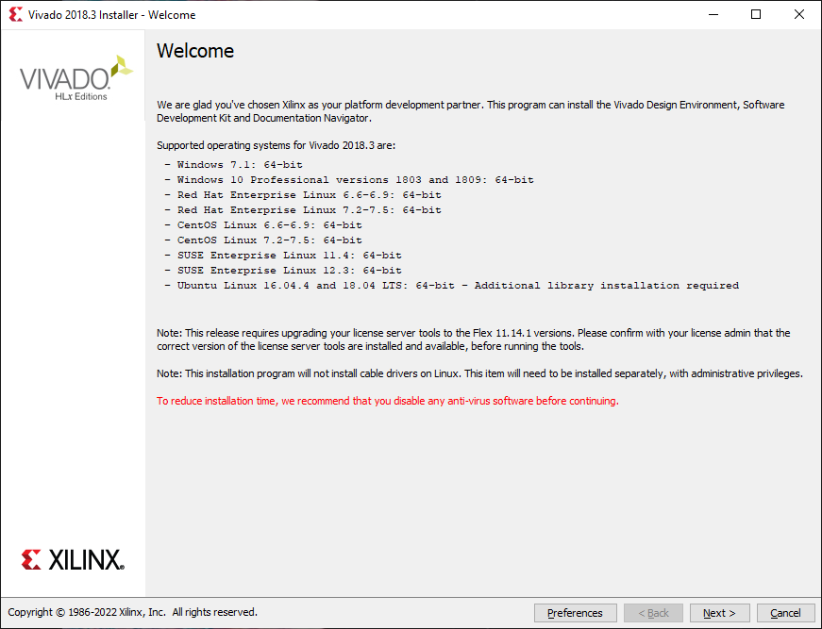

- Add your UserID/Password ( From the account you created previously) and Click Next

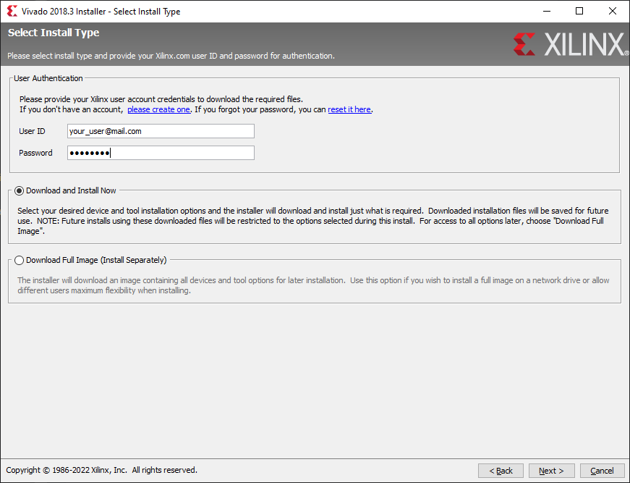

- Agree to Licenses and click Next
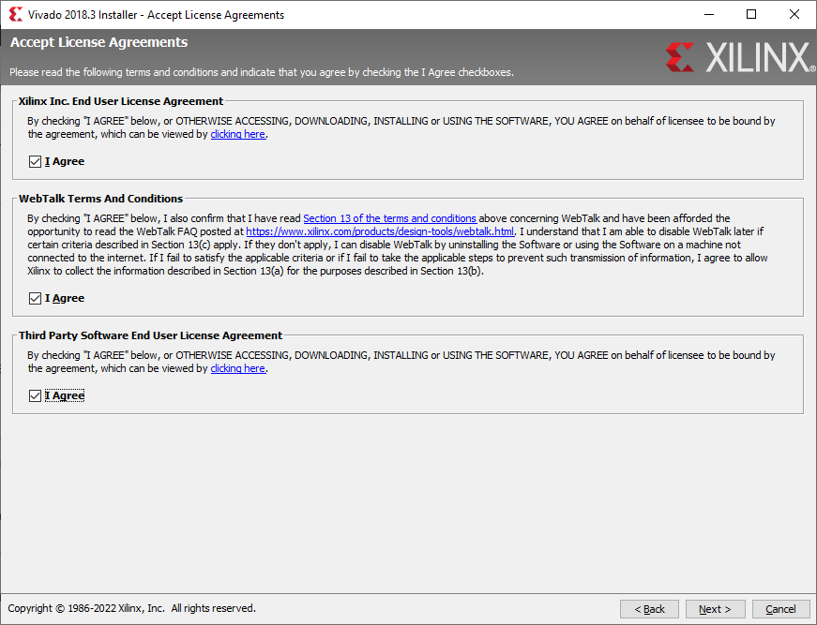

- Select HL WebPACK and click Next
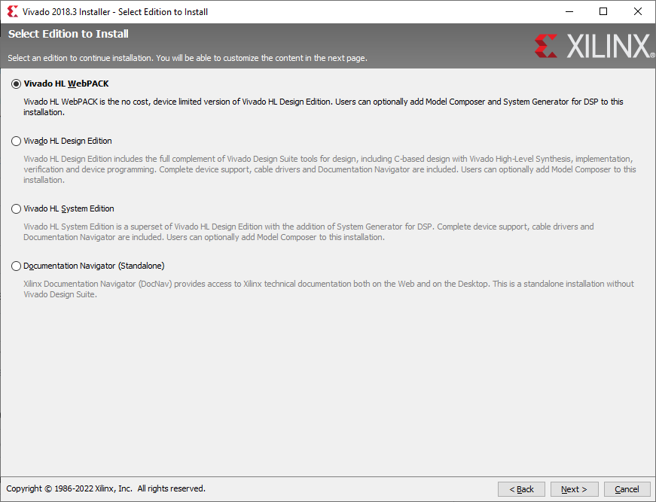
- Check the boxes like in the picture below and Click Next

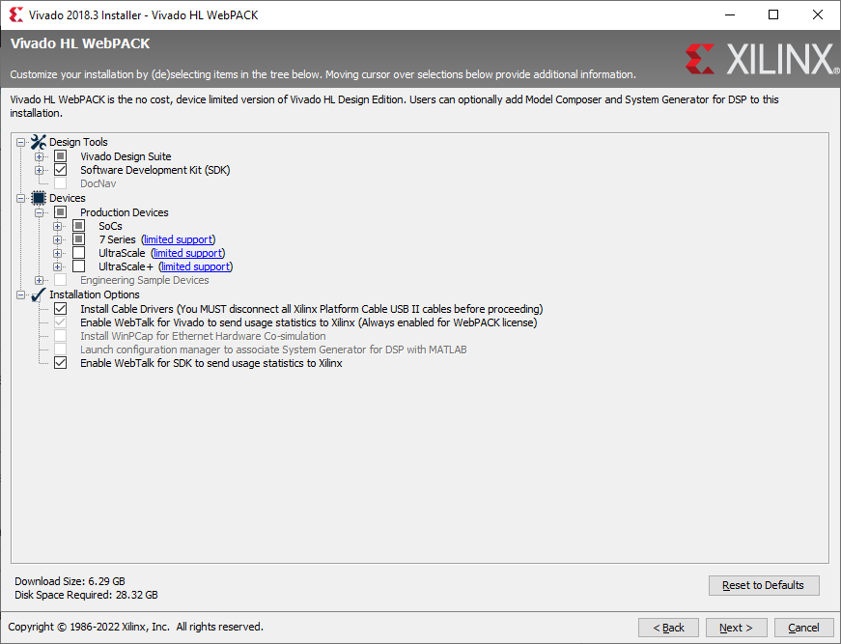

- Click Next to Destination Directory (Leave the default values)

- Review the installation Summary and click Install
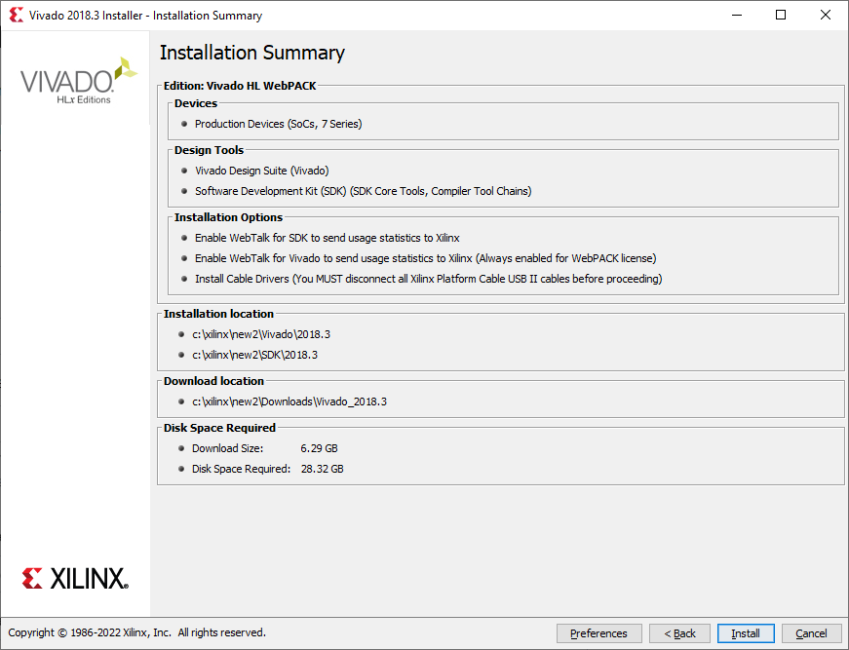
- The installation will need hours to complete. Don’t close the computer until finished

